CUSTOMER COMPLAINTS MANAGEMENT
SEPTODONT ARTICLE CODE | PRODUCT NAME | Please select the product concerned
10307P | DENTAPEN AM (22) | ☐
10306O | DENTAPEN UE (22) | ☐
0051U | DENTAPEN (UE) | ☐
0476I | DENTAPEN | ☐
10213Z | DENTAPEN (US) | ☐
10126S | DENTAPEN (US) | ☐
10296E | DENTAPEN COMPLETE KIT 2.2 ML | ☐
10300I | GRIP SERINGUE DENTAPEN SPINE SPIX | ☐
0050W | GRIP SERINGUE DENTAPEN SPINE SPIX | ☐
10177P | CORPS SERINGUE DENTAPEN (US) | ☐
10301J | CORPS SERINGUE DENTAPEN (US) | ☐
10304M | CORPS SERINGUE DENTAPEN (UE) | ☐
0050Z | CORPS SERINGUE DENTAPEN (UE) | ☐
0050Y | BATTERIE DENTAPEN | ☐
10302K | BATTERIE DENTAPEN | ☐
10303L | AILETTE POUR SERINGUE DENTAPEN | ☐
0050X | AILETTE POUR SERINGUE DENTAPEN | ☐
10305N | HOUSSE DE PROTECTION DENTAPEN | ☐
0051J | HOUSSE DE PROTECTION DENTAPEN | ☐

Septodont purchase order number

FOR INCIDENT REGARDING THE KIT (injector or any element of the kit – Battery/Cartridge holder/ Finger Grip/O-Ring/Sleeve
Septodont batch number concerned
Please refer to the receipt received for your purchasing order
Supplier batch number concerned
Device Serial Number
- On the Box
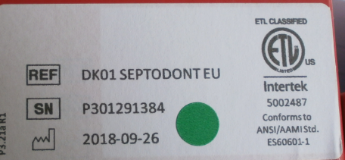
- On the device
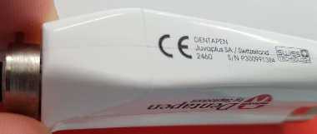
Please confirm if the Serial Number is the same on the box and the device | Yes ☐  No ☐
If the serial number between the box and the device is not the same, please confirm with the practitioner if there is not a mix | ………………………………………………….
Delivery date at the practitioner’s office
Is there a green label on the device? | Yes ☐  No ☐

SITUATION OF THE INCIDENT
IN CASE OF DAMAGED ITEM (accessory and Dentapen Injector)
Does the problem appear at the 1st use?
Please detail the situation of the incident (when? How? Condition of use? Etc…)
Has the damaged item been cleaned &/or sterilised? | Yes ☐  No ☐
If yes,
How many times?
Please describe the cleaning and sterilization conditions
Is the problem occurring with many accessories or one specifically?

IN CASE OF DEVICE MALFUNCTION (Dentapen injector)
Does the problem appear at the 1st use?
Please detail the situation of the incident (when? How? Condition of use? Etc…)
Has the damaged item been cleaned (type of product and protocol)?
If yes, How many times? | -
Please described the cleaning conditions
What is the color of the On/Off led while using the device?
- Green
- Orange
- Red
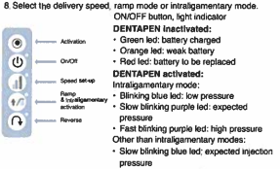
After detection of the problem, has the battery been changed?
By the Practioner?
By Internal teams? Oui
And if so, did the problem persist?

FOR OTHER INCIDENT
Does the problem appear at the 1st use? | ………………………………………………….
Please detail the situation of the incident (when? How? Condition of use? Etc…) | ………………………………………………….

